Updating and Validating the EUTCT formats

This document describes how to update the EUTCT formats program and the required validating process. Note that this is only required if the EudraCT work instruction states that updating the formats is necessary.

*Part A: Updating the EUTCT formats program*

1. Go to <http://eutct.ema.europa.eu/eutct/displayWelcome.do> and click on RMS.

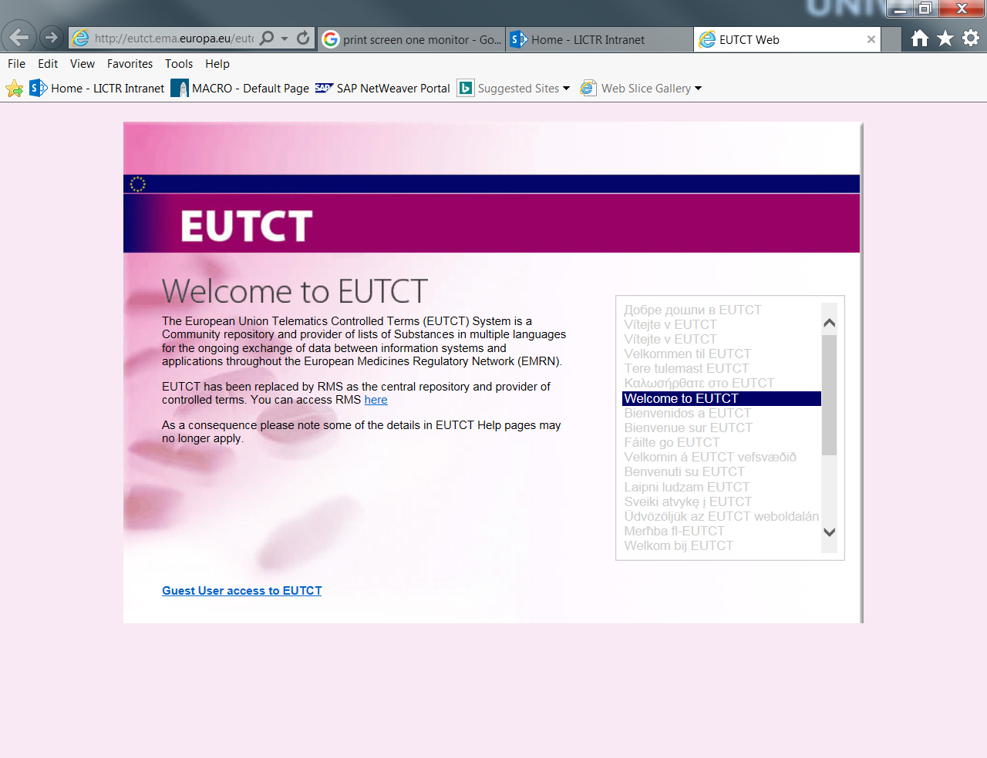

1. Click on lists and then view lists.

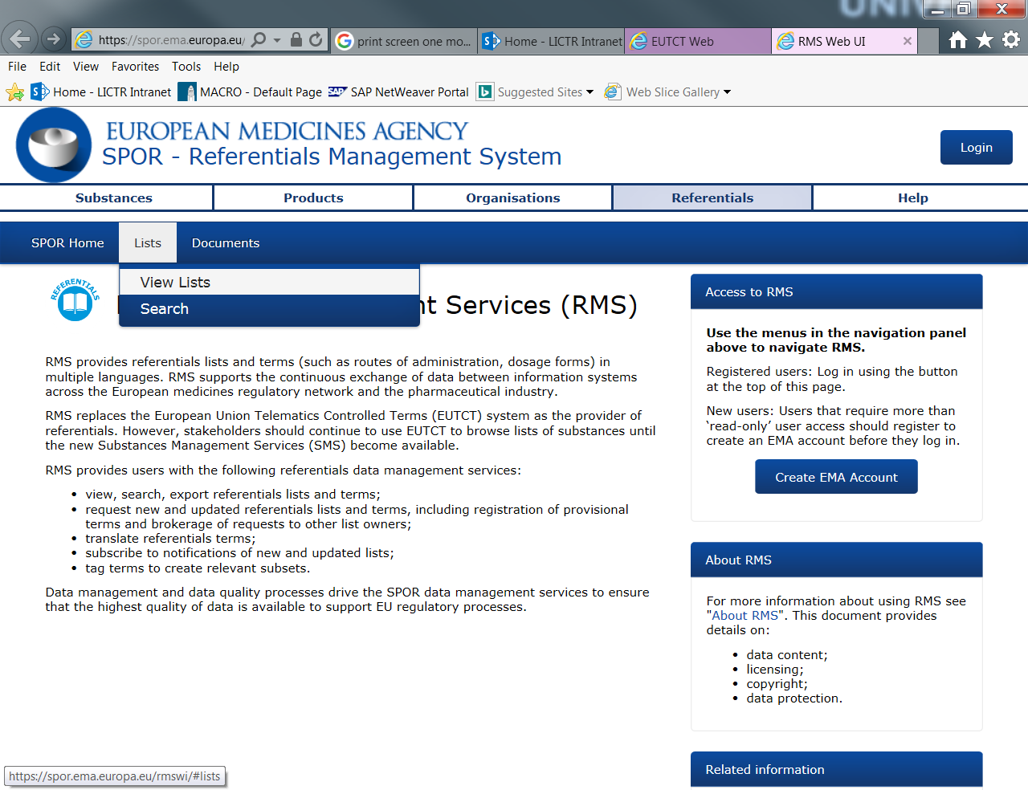

1. Find and click on Medical Dictionary for regulatory activities.

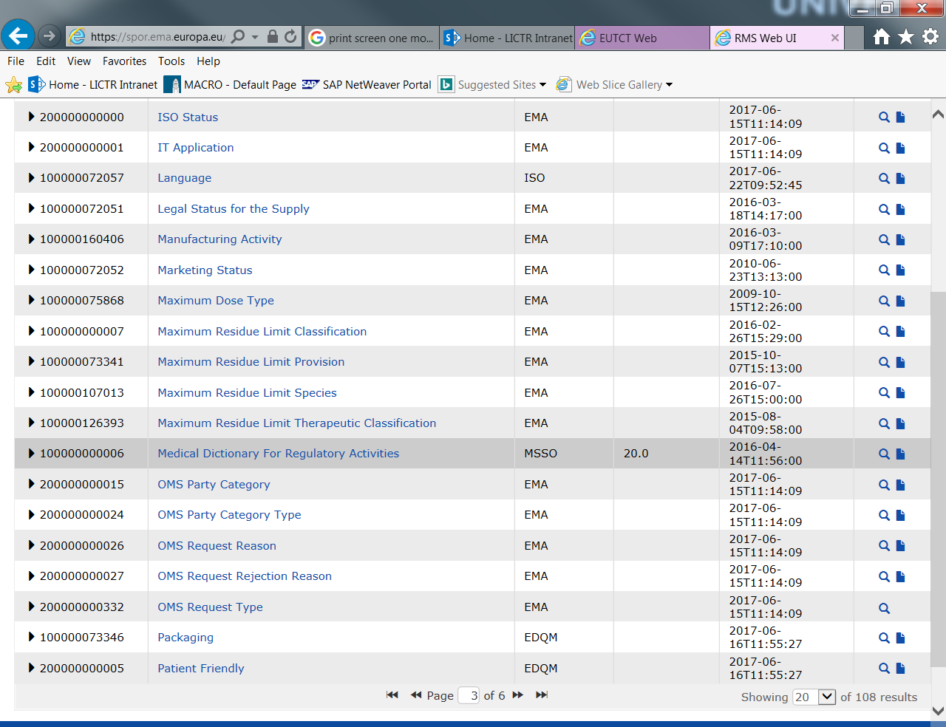

1. Create a new SAS program to define the EUCT formats library for this version using the format “term name” = identifier. Remember to change the ‘Version Number’ = X to the new version number. Save the formats program as EUTCT_formats_VX.sas.
2. The version number (X) can be found as follows;
   1. From step III click on any term

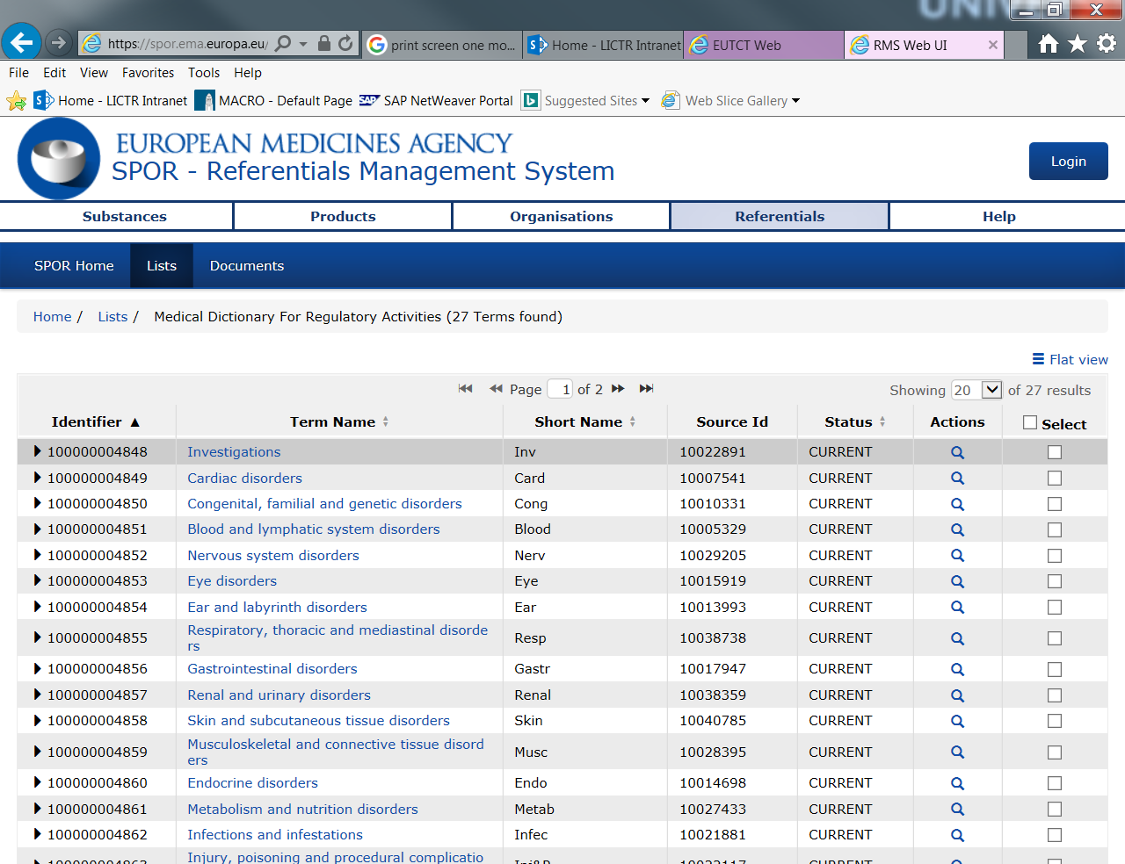

* 1. Expand “operational attributes”, the version number should be clearly stated.

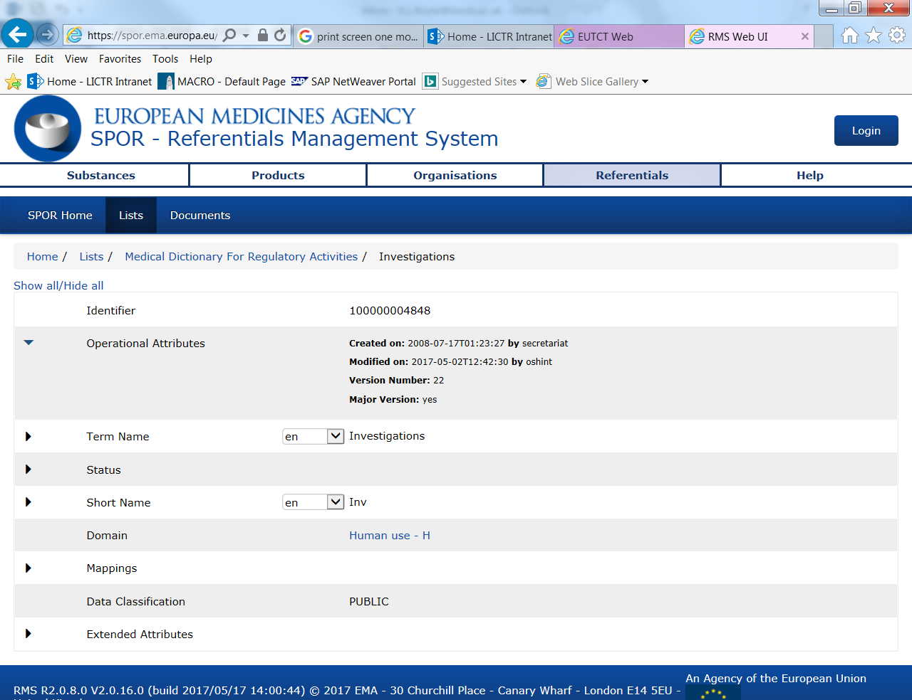

*Part B: Validating the EUTCT formats program*

The programs for this part can be found here: P:\CTRU\Stats\Programming\SAS\Eudract\EudraCT_FormatsValidation\V22.

A new sub-directory should be made in order to track the new validation process: P:\CTRU\Stats\Programming\SAS\Eudract\EudraCT_FormatsValidation\VX

V22 was validated using two steps; Scenario C and Upload. Descriptions of the tests and the example data and programs used are linked below but it is up to the individual validating to ensure that the process is appropriate for the new update.

1. Scenario C: That the data checker program correctly identifies incorrect SOCs

Programs: P:\CTRU\Stats\Programming\SAS\Eudract\EudraCT_FormatsValidation\V22\SASprogs\ScenarioC

Data: P:\CTRU\Stats\Programming\SAS\Eudract\EudraCT_FormatsValidation\V22\SASdata\ScenarioC

| # | Test | Expected Result |
| --- | --- | --- |
| 1 | EudractAE   * Adding a typo to “Ear and labyrinth disorders” so it won’t match up properly. | The following error message will show, stating which SOC is wrong.  ERROR: Ear and labirinth disorders hasn't matched, check the format or input dataset |
| 2 | EudractSAE   * Adding a typo to “Renal and urinary disorders” so it won’t match up properly. | The following error message will show, stating which SOC is wrong.  ERROR: Renel and urinary disorders hasn't matched, check the format or input dataset |

1. Upload: That the upload works correctly if all 26 SOC’s (according to CTCAE V4.0) are included

Programs: P:\CTRU\Stats\Programming\SAS\Eudract\EudraCT_FormatsValidation\V22\SASprogs\Upload

Data: P:\CTRU\Stats\Programming\SAS\Eudract\EudraCT_FormatsValidation\V22\SASdata\Upload

| # | Test | Expected Result |
| --- | --- | --- |
| 1 | EudractSAE was created to include all 26 CTCAE SOC terms and put through the program. Each SOC was checked manually to ensure it matched what should have been uploaded. | Each SOC should be recorded correctly on the EudraCT database. |

Once the validation has been completed successfully the new formats program should be copied to the folder structure P:\CTRU\Stats\Programming\SAS\Eudract\EudraCT_Upload_VX+1.0 and superseding the prior version correctly.